Design Document
Sortable Coding Challenge
Ermenildo Castro
01/22/16

Contents:
Setup
Summary
Requirements
Implementation
Algorithm Analysis
Veracity Tests

X) SETUP
X) REQUIREMENTS
Project goals:
Precision is critical; reduce false-positives (lower recall)
IMPLEMENTATION

Feature_Extractor.py
Product.txt listing is used as the training set for determining the valid TAGs. A TAG is a mutually exclusive category. Within Feature_Extractor.py, the TAG groups mirror the classification properties of each Product json object: product_name; manufacturer; family; model; announced_date. For each object in the Product.txt listing, Feature_Extractor.py, processObject function is invoked to extract the product content, and assign it into its appropriate TAG collection.
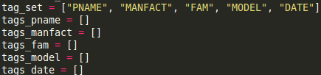
Figure FE.0
Dictionary collection of each valid tag. Contained within Feature_Extractor.py.

Each valid TAG is hashed into their respective TAG collections (pname, manfact, et cetera.). The collection of valid TAG sets allows for quick extraction of valid TAGS through logarithmic binary search, provided that each TAG collection is sorted in pre-processing. However, efficient processing only exists for syntactically exact matches. While validating only syntactically exact matches increases precision, recall is significantly affect. Observe that “T11 31,” a model TAG, will fail to match to the the product TAG, “T11-31” despite their similarities.
Product_Feature.py increases recall for near matches by exploiting the value relationships in each TAG collection. Through unigram modeling techniques, any unknown TAG, UNK, will undergo string approximation calculation. However, string approximation is computationally space and time expensive. Therefore, performing string approximation on all possible TAGs is unreasonable. It follows that in order to maintain precision, while increasing recall reducing computation costs that string approximation only be conducted on a small (~30) candidate subset. The candidate subset is determined through unigram inference.
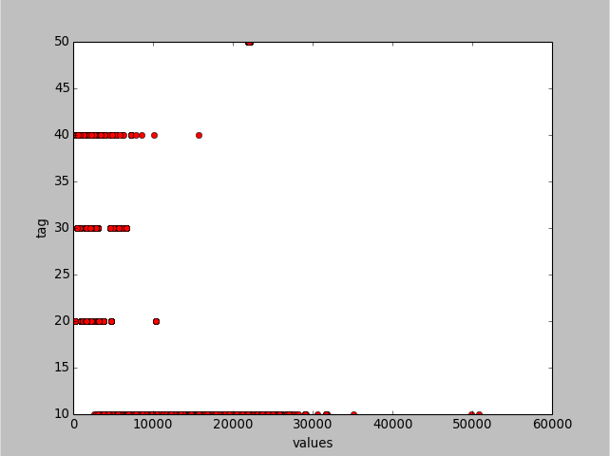
Figure FE.1
The hash values (X-coordinate) ordered by their known TAG category (Y-coordinate).
50 = tags “date”
40 = tags “model”
30 = tags “family”
20 = tags “manufacturer”
10 = tags “product name”
Feature_Extractor.py uses only categories {model, family, manufacturer} as key identification categories because product name and date are insignificant in contributing to the identification of a product : listing pair.

From figure FE.1, observe that each TAG grouping is approximately normally distributed. This observation allows Feature_Extractor.py to extract a candididate subset of tags by their statistical likelihood. Thus, the UNK tag value is hashed, then the TAG category's mean that is closest to the UNK hash value is selected as the likely category. Following the category selection from either “model,” “family,” or “manufacturer” (categories of primary interest), the candidate subsets are extracted to be 1+/- standard deviation away from the current UNK hash value.

